Alexander Zayas

Sept 5th, 2024

Module 6.3

HTML Validator Results

Homepage/Landing Page

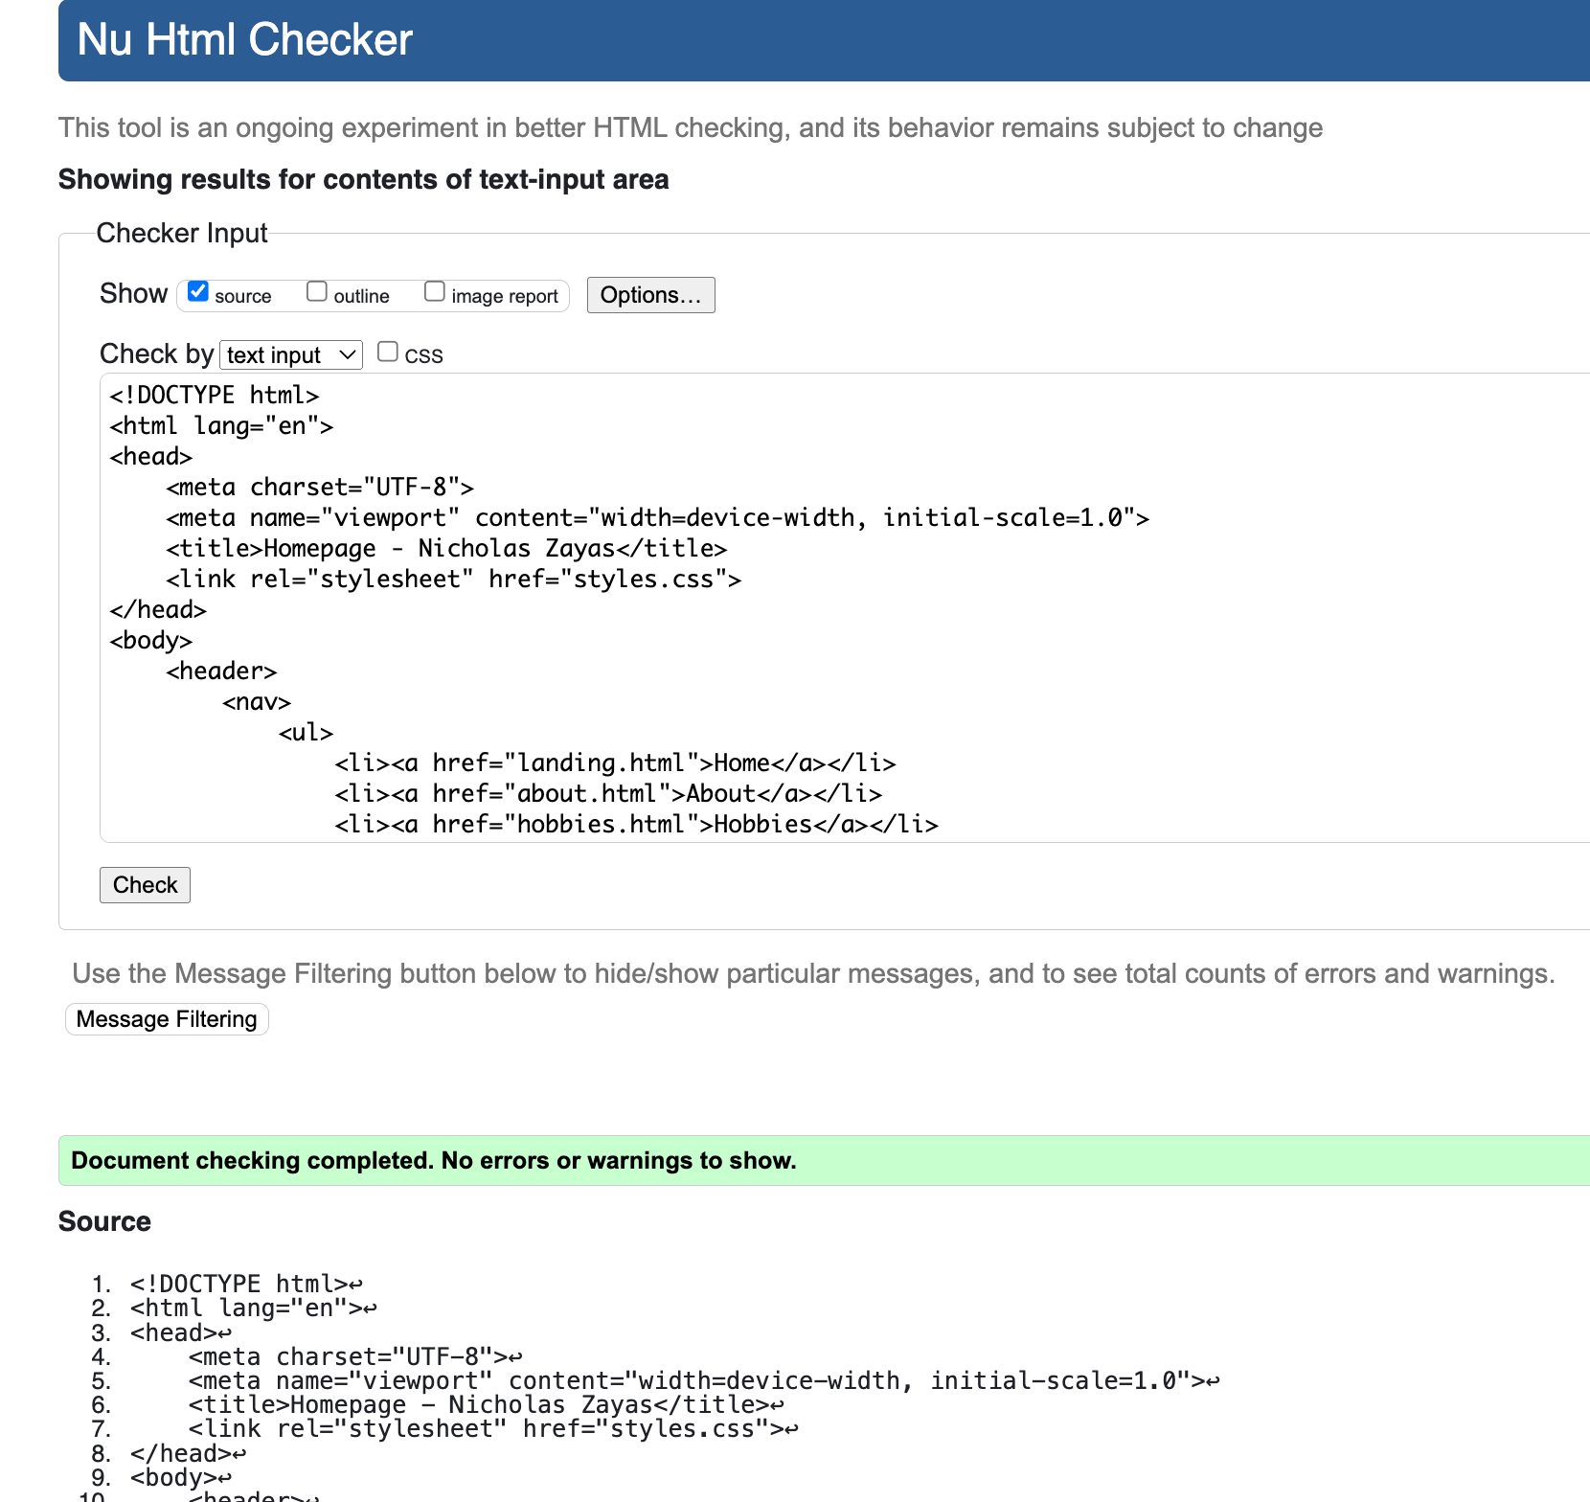

About Page

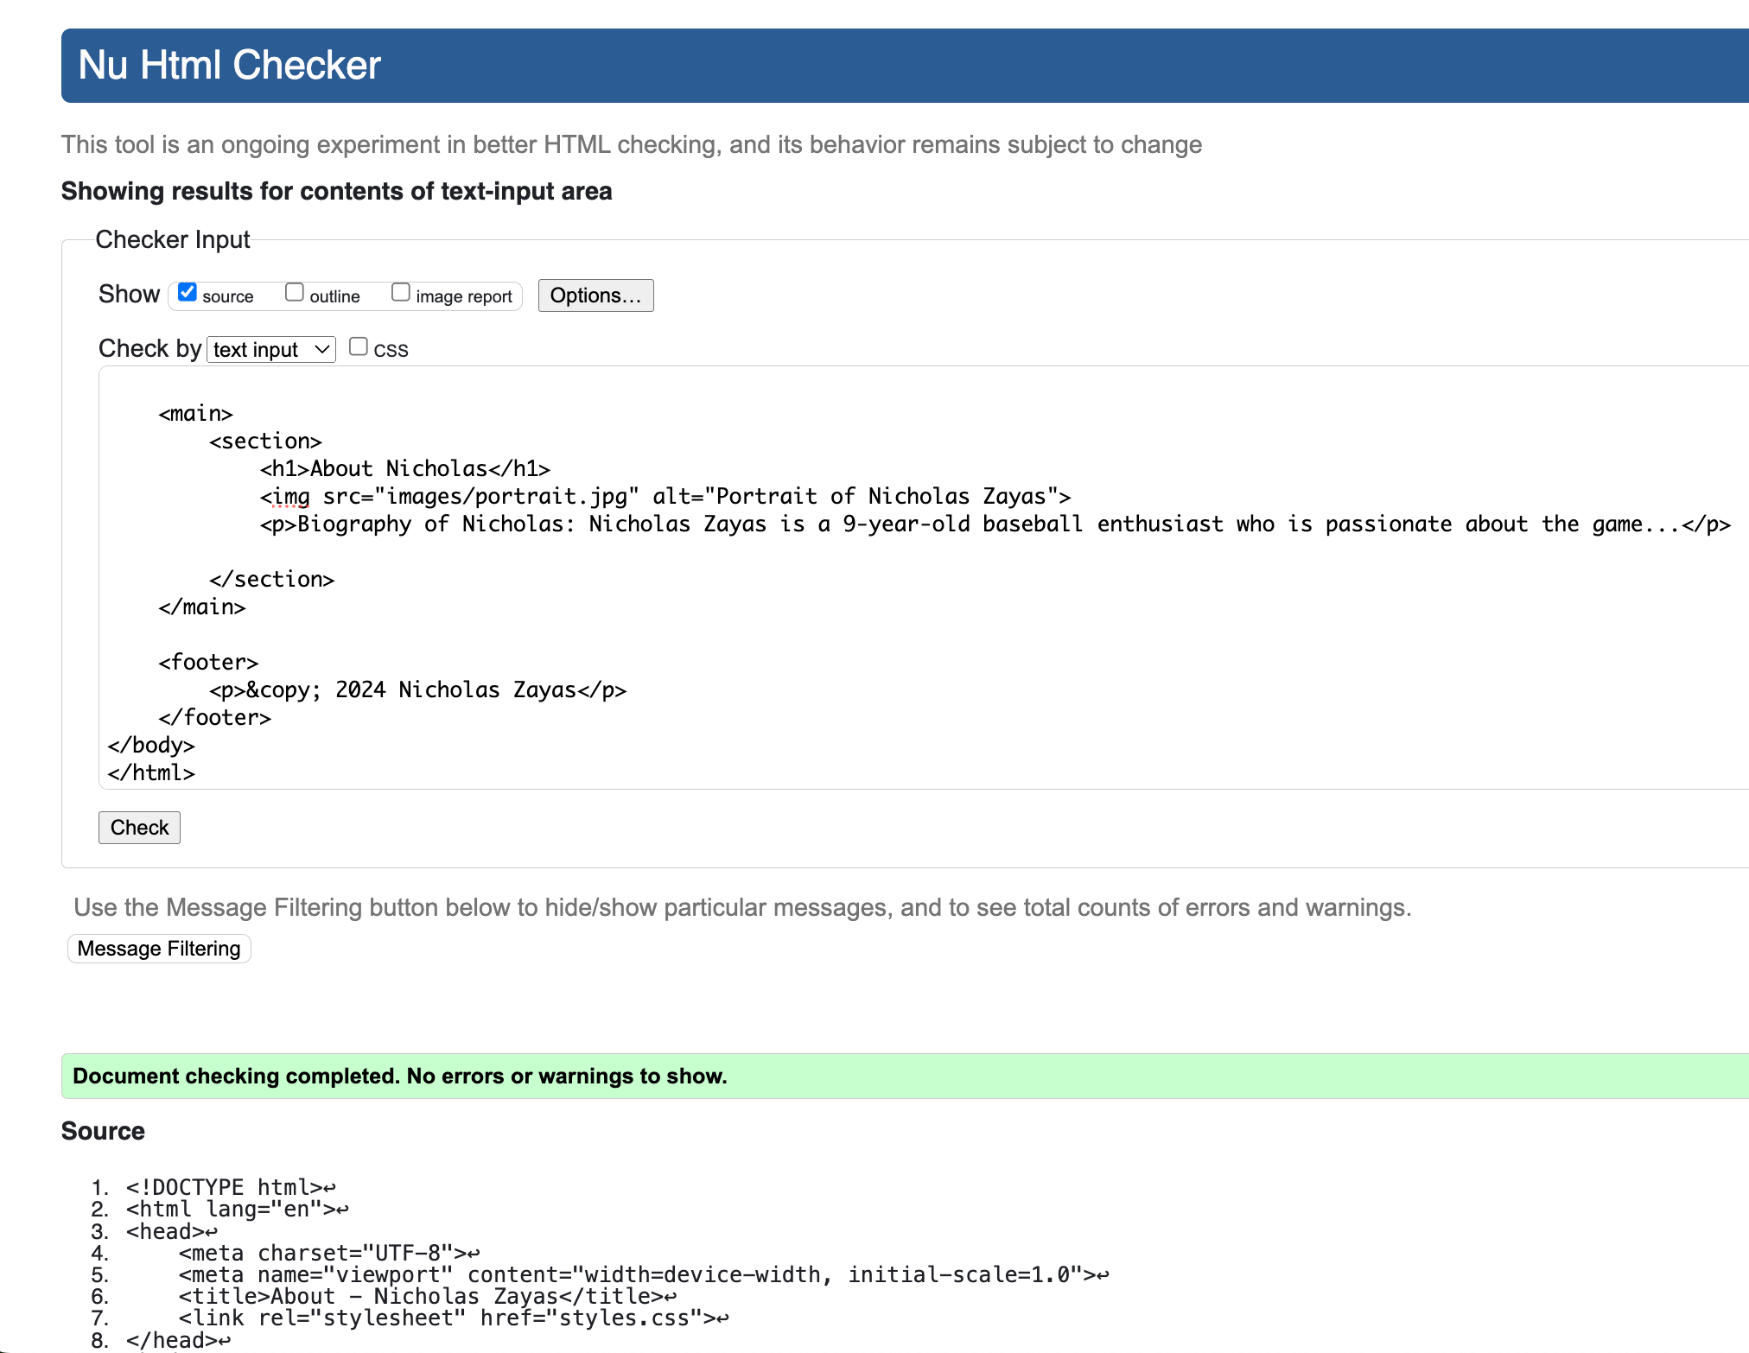

Hobbies Page

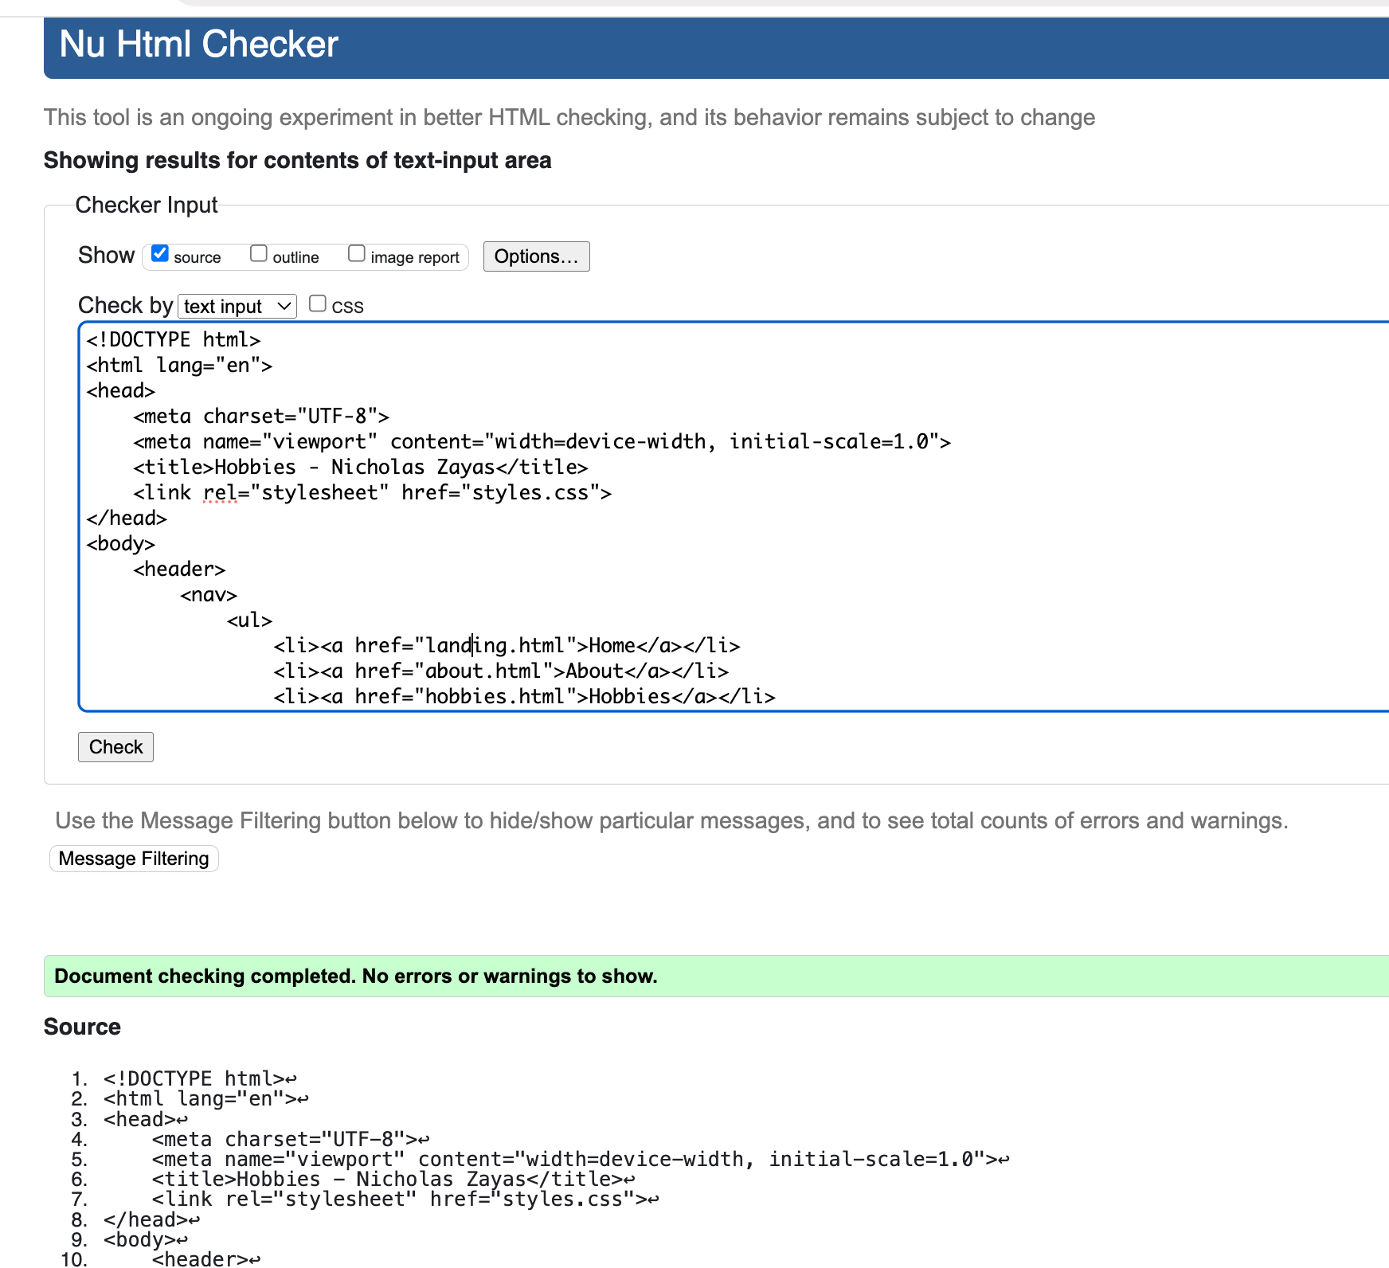

CSS Validation

